Assignment-3
2503B09902-MCA
SANNITHA G

Task:1
Problem-01:
A bit stream 1101011011 is transmitted using the standard CRC method. The generator polynomial is x⁴+x+1. What is the actual bit string transmitted?
Code:
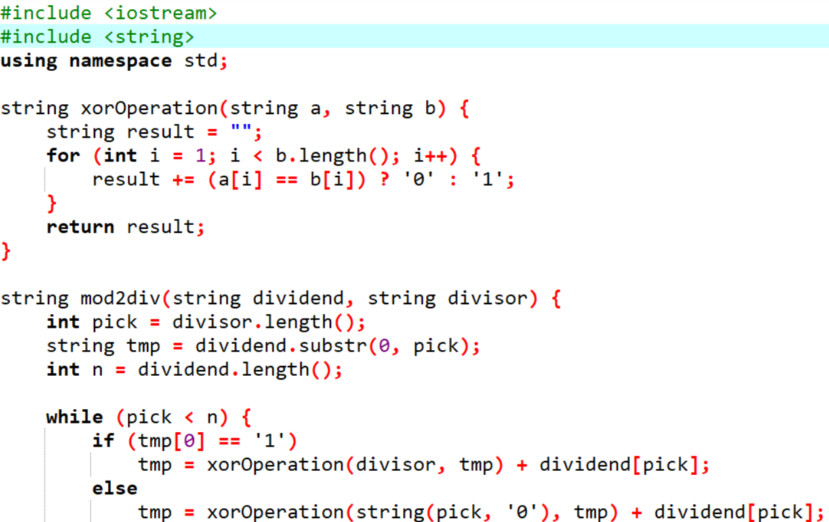
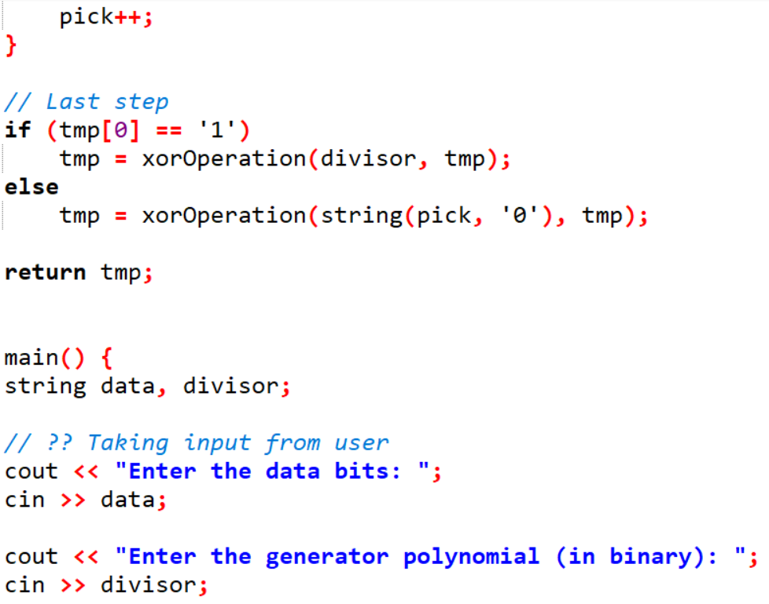
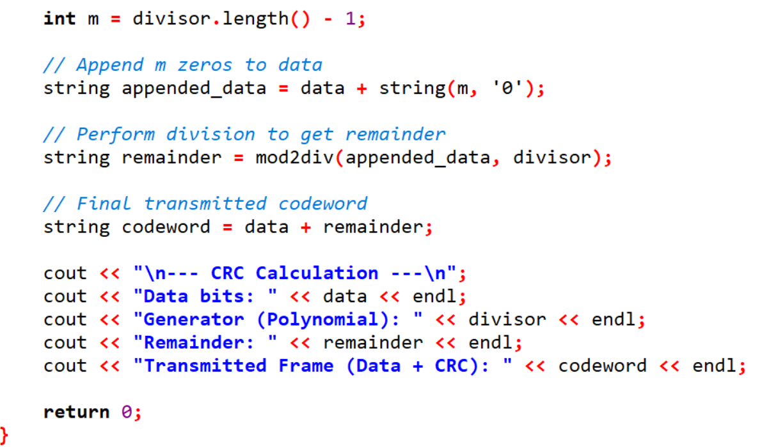

Output:
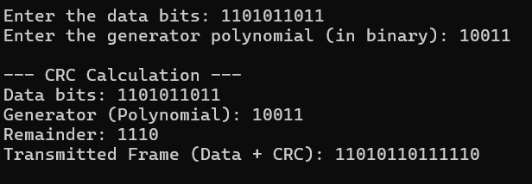
Task:2
Problem-02:
A bit stream 10011101 is transmitted using the standard CRC method. The generator polynomial is x³+1.
- What is the actual bit string transmitted?
- Suppose the third bit from the left is inverted during transmission. How will receiver detect this error?
Code:
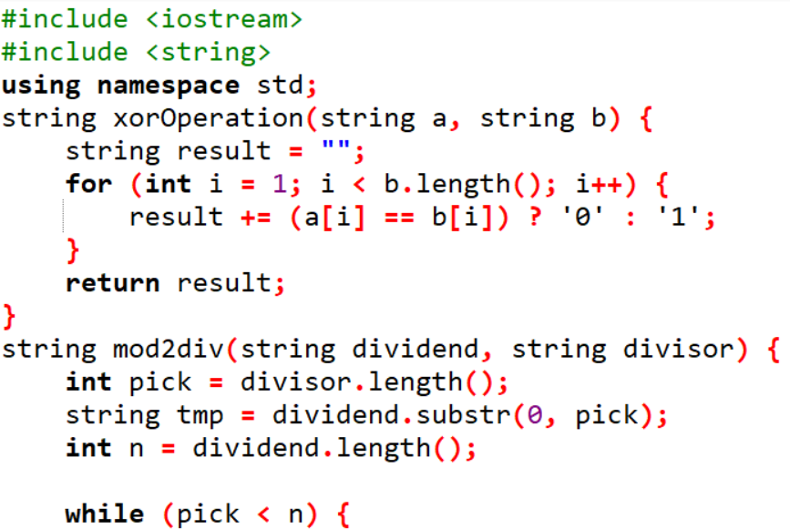
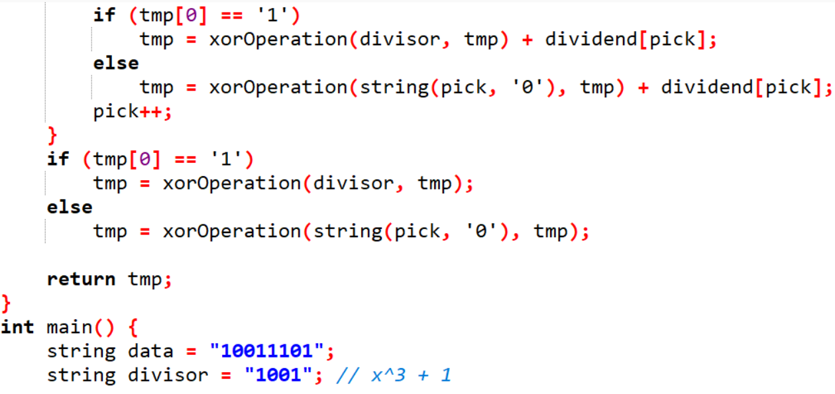
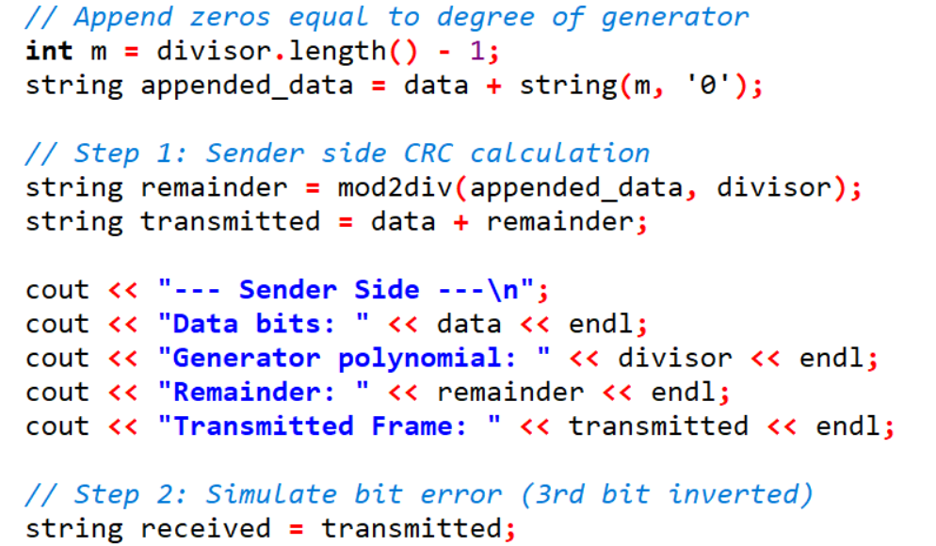
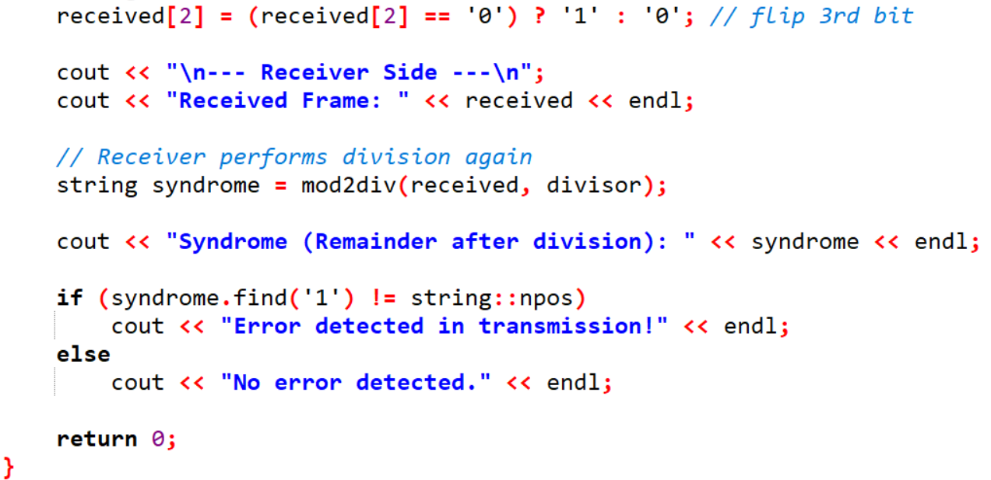
Output:
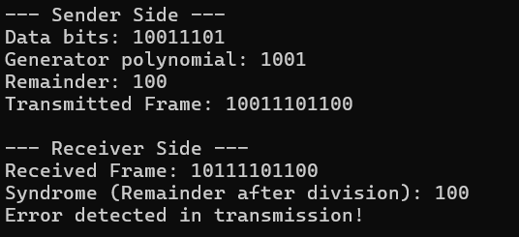

Explanation
Step | Description | Result
1 | Generator: x³ + 1 → binary 1001 | Degree = 3
2 | Append 3 zeros to data | 10011101000
3 | Divide using XOR | Remainder = 100
4 | Transmit = Data + Remainder | 10011101100
5 | Invert 3rd bit | Received = 10111101100
6 | Divide received data | Syndrome = 100 → Error detected ✅

